AI-TEAM04
Week 2: Exploratory Data Analysis, Data Insights and Visualization Report

Intern Name: Laiba Jawaid
Date of Submission: 25 August, 2025

Team Members:
- Hammad Mengrani
- Kareem Mamdouh
- Laiba Jawaid
- Priyanka Kute
- Reeba Joshi
- Rifat Islam
- Sumaya Mateen

Cleaned Dataset Link:
https://docs.google.com/spreadsheets/d/1jYJRve1G7gzYCmadyMgdVmbcAiEe0enQ2SehPKfkqJQ/edit?usp=sharing

EDA & Data Visualization Link:
https://colab.research.google.com/drive/1O0zFZCOk51iBnyChvkhB9bT3ZQaeDVpX?usp=sharing

- Introduction
- Purpose:
The primary objective of Week 2 was to perform a comprehensive Exploratory Data Analysis (EDA), including Data Visualization and Insight Extraction, on the cleaned and feature-engineered dataset. The purpose of this report is to document the trends, patterns, correlations, and anomalies observed within the data, and to generate visualizations that effectively communicate these insights. This analysis provides a foundation for making data-driven decisions and formulating recommendations to enhance learner engagement and improve opportunity success rates.
- Data Description:
The dataset contains 8,558 rows and 47 columns. Each row represents a learner’s application to an opportunity, while the columns capture learner demographics, opportunity details, application timing, behavioral features, and engagement metrics. A detailed description of each column is provided below:
Column Name | Data Type | Description
Learner SignUp DateTime | datetime64[ns] | Date and time when the learner signed up.
Opportunity Id | object | Identifier for each opportunity.
Opportunity Name | string | Name of the opportunity/program.
Opportunity Category | string | Category/group of the opportunity (e.g., internship, training).
Opportunity End Date | datetime64[ns] | End date of the opportunity.
First Name | string | Learner’s first name.
Date of Birth | datetime64[ns] | Learner’s date of birth.
Gender | string | Gender of the learner.
Country | string | Country of the learner.
Institution Name | string | Institution/university of the learner.
Current/Intended Major | string | Learner’s current or intended field of study.
Entry created at | datetime64[ns] | Timestamp when the application entry was created.
Status Description | string | Status of the application (e.g., Completed, In Progress, Withdrawn).
Status Code | int64 | Numeric code representing application status.
Apply Date | datetime64[ns] | Date when the learner applied.
Opportunity Start Date | datetime64[ns] | Start date of the opportunity.
Age | int64 | Age of the learner at sign-up.
Current_Age | float64 | Current calculated age of the learner.
Age_Group | string | Age group classification (e.g., 18–22, 23–30).
Signup_to_Apply_Days | float64 | Days between signup and application.
Course_Duration_Days | float64 | Duration of the opportunity in days.
Signup_Month | Int64 | Month of sign-up (numeric).
Signup_Weekday | string | Day of the week of sign-up.
Signup_Hour | Int64 | Hour of the day when sign-up occurred.
Is_Weekend_Signup | Int64 | Indicator (1/0) if sign-up was on a weekend.
Quick_Applicant | Int64 | Indicator (1/0) if the learner applied quickly after sign-up.
Invalid_Application_Timing | Int64 | Indicator (1/0) for invalid timing of application.
Gender_Encoded | Int64 | Encoded numerical value for gender.
Region | string | Region of the learner.
Major_Category | string | Group/category of the learner’s major.
Is_Successful | Int64 | Indicator (1/0) if the application was successful.
Same_Day_Application | Int64 | Indicator (1/0) if the learner applied on the same day as sign-up.
Late_Applicant | Int64 | Indicator (1/0) if the learner applied late compared to signup.
Opportunity_Popularity | float64 | Popularity score of the opportunity (e.g., based on applications).
Popular_Opportunity | Int64 | Indicator (1/0) if opportunity is considered popular.
Age_Major_Combo | string | Combined feature of Age Group and Major.
Country_Gender | string | Combined feature of Country and Gender.
Region_Opportunity | string | Combined feature of Region and Opportunity.
Engagement_Score | float64 | Score representing learner engagement.
Engagement_Level | string | Engagement level category (e.g., Low, Medium, High).
Apply_vs_Start_Gap | int64 | Days between application date and opportunity start date.
Applications_per_User | int64 | Number of applications submitted by the learner.
Unique_Categories_per_User | int64 | Count of unique opportunity categories applied by the learner.
Region_AgeGroup | string | Combined feature of Region and Age Group.
Applications_for_Opportunity | int64 | Number of applications received for the specific opportunity.
Region_Normalized_Applications | float64 | Normalized application count for a region.
User_Success_Rate | float64 | Success rate of the learner’s applications.

- Data Cleaning Process
Here are the approaches used for cleaning the dataset:
- Converted columns to their appropriate data types (e.g., Datetime, INT, Object, Float)
- Trimmed extra and unnecessary white spaces across all fields.
- Cleaned and standardized key text columns (Name, Major, Institution, Country) by:
- Correcting misspellings and variations.
- Removing invalid or unusually short entries.
- Stripping digits and symbols.
- Normalizing spaces.
- Ensuring consistent capitalization.
- Mapping inconsistent values to standard forms.
- Translating non-English text into English for consistency.
- Checked for duplicate records in the dataset.
- Filled missing values as follows:
- “First Name” nulls replaced with “Not Specified”.
- For “Institution Name and Current/Intended Major” applied group-based imputation (grouped by First Name, Date of Birth, Country) to fill missing values with the first non-null entry; remaining nulls replaced with “Not Specified”.
- Filled missing values in “Opportunity Start Date” with the mode date of each group, after grouping by Opportunity Name.
- For missing values in Opportunity Start Date (Competition category only), calculated the average duration between start and end dates and imputed missing start dates by subtracting this duration from the corresponding end date.
These steps ensured accuracy, consistency, and completeness of the data.

3. Exploratory Data Analysis (EDA):
Unique Value Analysis:
The unique value analysis provides an overview of the diversity and distinctiveness of entries across all dataset columns.
- Date & DateTime Columns
- Learner SignUp DateTime: 3907 unique values
- Opportunity End Date: 17 unique values
- Date of Birth: 2620 unique values
- Entry created at: 94 unique values
- Apply Date: 8483 unique values
- Opportunity Start Date: 20 unique values
- Categorical Columns
  - Opportunity Id: 23 unique values
  - Opportunity Name: 22 unique values
  - Opportunity Category: 5 unique values
  - First Name: 2864 unique values
  - Gender: 4 unique values
  - Country: 70 unique values
  - Institution Name: 1466 unique values
  - Current/Intended Major: 341 unique values
  - Status Description: 8 unique values
  - Status Code: 8 unique values
  - Signup_Weekday: 7 unique values
  - Signup_Month: 12 unique values
  - Region: 5 unique values
  - Major_Category: 4 unique values
  - Age_Major_Combo: 20 unique values
  - Country_Gender: 118 unique values
  - Region_Opportunity: 23 unique values
  - Region_AgeGroup: 24 unique values
  - Age_Group: 5 unique values
  - Engagement_Level: 3 unique values
- Numeric Columns
  - Age: 42 unique values
  - Current_Age: 43 unique values
  - Signup_to_Apply_Days: 727 unique values
  - Course_Duration_Days: 25 unique values
  - Signup_Hour: 24 unique values
  - Gender_Encoded: 4 unique values
  - Opportunity_Popularity: 22 unique values
  - Engagement_Score: 10 unique values
  - Apply_vs_Start_Gap: 1018 unique values
  - Applications_per_User: 33 unique values
  - Unique_Categories_per_User: 5 unique values
  - Applications_for_Opportunity: 23 unique values
  - Region_Normalized_Applications: 50 unique values
  - User_Success_Rate: 76 unique values
- Binary Columns
- Is_Weekend_Signup: 2 unique values
- Quick_Applicant: 2 unique values
- Invalid_Application_Timing: 2 unique values
- Is_Successful: 2 unique values
- Same_Day_Application: 2 unique values
- Late_Applicant: 2 unique values
- Popular_Opportunity: 2 unique values

Outliers (With Box Plot):
The outlier analysis identifies extreme values in numeric variables that deviate significantly from the typical range. Boxplots were used to visually detect these outliers.
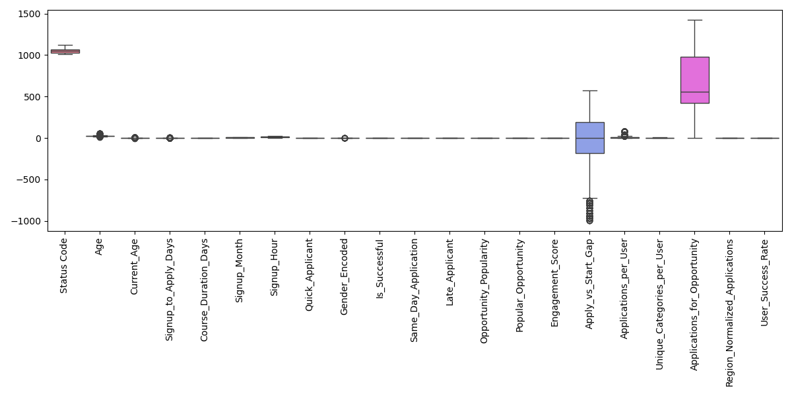Outliers (With Code):
- Status Code: 0 outliers
- Age: 488 outliers
- Current_Age: 640 outliers
- Signup_to_Apply_Days: 661 outliers
- Course_Duration_Days: 0 outliers
- Signup_Month: 0 outliers
- Signup_Hour: 0 outliers
- Quick_Applicant: 0 outliers
- Gender_Encoded: 15 outliers
- Is_Successful: 0 outliers
- Same_Day_Application: 0 outliers
- Late_Applicant: 0 outliers
- Opportunity_Popularity: 0 outliers
- Popular_Opportunity: 0 outliers
- Engagement_Score: 0 outliers
- Apply_vs_Start_Gap: 92 outliers
- Applications_per_User: 486 outliers
- Unique_Categories_per_User: 0 outliers
- Applications_for_Opportunity: 0 outliers
- Region_Normalized_Applications: 0 outliers
- User_Success_Rate: 0 outliers

Statistical Summary :
The statistical summary provides an overview of the key numerical features in the dataset. It includes measures such as count, mean, standard deviation, minimum, maximum, quartiles, and range.

Column Name | Count | Mean | Std | Min | 25% | 50% | 75% | Max | Range
Status Code | 8,558 | 1052.23 | 21.67 | 1010.00 | 1030.00 | 1050.00 | 1070.00 | 1120.00 | 110.00
Age | 8,558 | 25.39 | 4.40 | 6.00 | 23.00 | 25.00 | 27.00 | 59.00 | 53.00
Current_Age | 8,558 | 0.00 | 1.00 | -4.40 | -0.54 | -0.08 | 0.37 | 7.65 | 12.05
Signup_to_Apply_Days | 8,558 | -0.00 | 1.00 | -3.59 | -0.47 | -0.47 | 0.49 | 4.40 | 7.99
Course_Duration_Days | 8,558 | 0.00 | 1.00 | -1.10 | -0.74 | -0.31 | 0.59 | 1.91 | 3.01
Signup_Month | 8,558 | 6.21 | 3.47 | 1.00 | 3.00 | 6.00 | 9.00 | 12.00 | 11.00
Signup_Hour | 8,558 | 12.31 | 6.83 | 0.00 | 6.00 | 13.00 | 18.00 | 23.00 | 23.00
Quick_Applicant | 8,558 | 0.52 | 0.50 | 0.00 | 0.00 | 1.00 | 1.00 | 1.00 | 1.00
Gender_Encoded | 8,558 | 1.42 | 0.50 | 1.00 | 1.00 | 1.00 | 2.00 | 4.00 | 3.00
Is_Successful | 8,558 | 0.48 | 0.50 | 0.00 | 0.00 | 0.00 | 1.00 | 1.00 | 1.00
Same_Day_Application | 8,558 | 0.40 | 0.49 | 0.00 | 0.00 | 0.00 | 1.00 | 1.00 | 1.00
Late_Applicant | 8,558 | 0.39 | 0.49 | 0.00 | 0.00 | 0.00 | 1.00 | 1.00 | 1.00
Opportunity_Popularity | 8,558 | 0.00 | 1.00 | -1.75 | -0.72 | -0.37 | 0.68 | 1.78 | 3.52
Popular_Opportunity | 8,558 | 0.47 | 0.50 | 0.00 | 0.00 | 0.00 | 1.00 | 1.00 | 1.00
Engagement_Score | 8,558 | 0.47 | 0.31 | 0.00 | 0.20 | 0.40 | 0.65 | 1.00 | 1.00
Apply_vs_Start_Gap | 8,558 | -22.72 | 291.01 | -998.00 | -181.00 | 1.00 | 189.00 | 570.00 | 1568.00
Applications_per_User | 8,558 | 8.33 | 10.48 | 1.00 | 2.00 | 5.00 | 11.00 | 83.00 | 82.00
Unique_Categories_per_User | 8,558 | 2.25 | 1.26 | 1.00 | 1.00 | 2.00 | 3.00 | 5.00 | 4.00
Applications_for_Opportunity | 8,558 | 705.87 | 404.97 | 4.00 | 419.00 | 559.00 | 980.00 | 1423.00 | 1419.00
Region_Normalized_Applications | 8,558 | 0.49 | 0.29 | 0.00 | 0.29 | 0.39 | 0.69 | 1.00 | 1.00
User_Success_Rate | 8,558 | 0.48 | 0.34 | 0.00 | 0.22 | 0.49 | 0.69 | 1.00 | 1.00
Dataset Health Check:
- Shape: 8,558 rows × 47 columns
- Numerical: 23 features
- Categorical: 18 features
- Datetime: 6 features
- Total Missing: 0 (0.0%)
- Duplicates: 0 rows

- Data Visualization
Data visualization helps to understand trends, patterns, and insights from large, complex datasets that might otherwise be hidden in raw numbers. Here are few visuals:

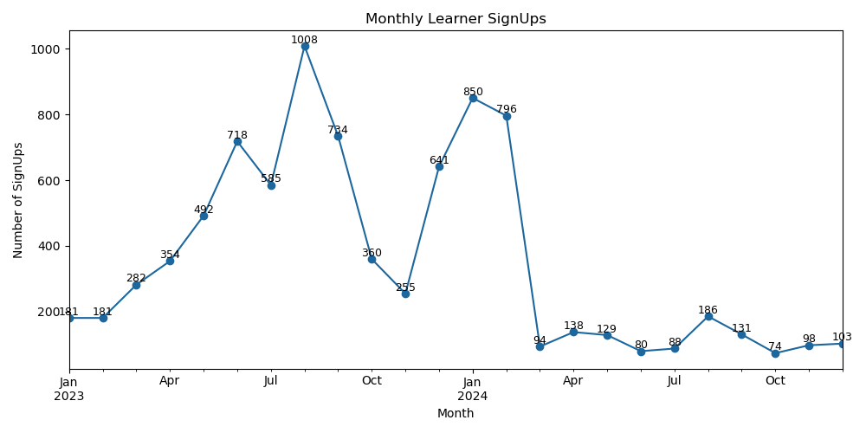
- Monthly Learners SignUps:

Insights:
- Rapid Growth & Peak (Jan–Aug 2023): Signups steadily increased, peaking at 1008 in Aug 2023, showing strong early adoption.
- Decline After Peak (Sep–Dec 2023): Sharp drop in signups after August, falling to nearly one-fourth by October.
- Second Surge (Jan–Feb 2024): A strong rebound occurred in early 2024, with 850–796 signups, likely campaign or seasonal-driven.
- Sustained Low Levels (Mar–Dec 2024): After Feb 2024, signups fell drastically and stabilized below 200/month, indicating difficulty in maintaining long-term momentum.

- Correlation of Application and User Success Metrics:
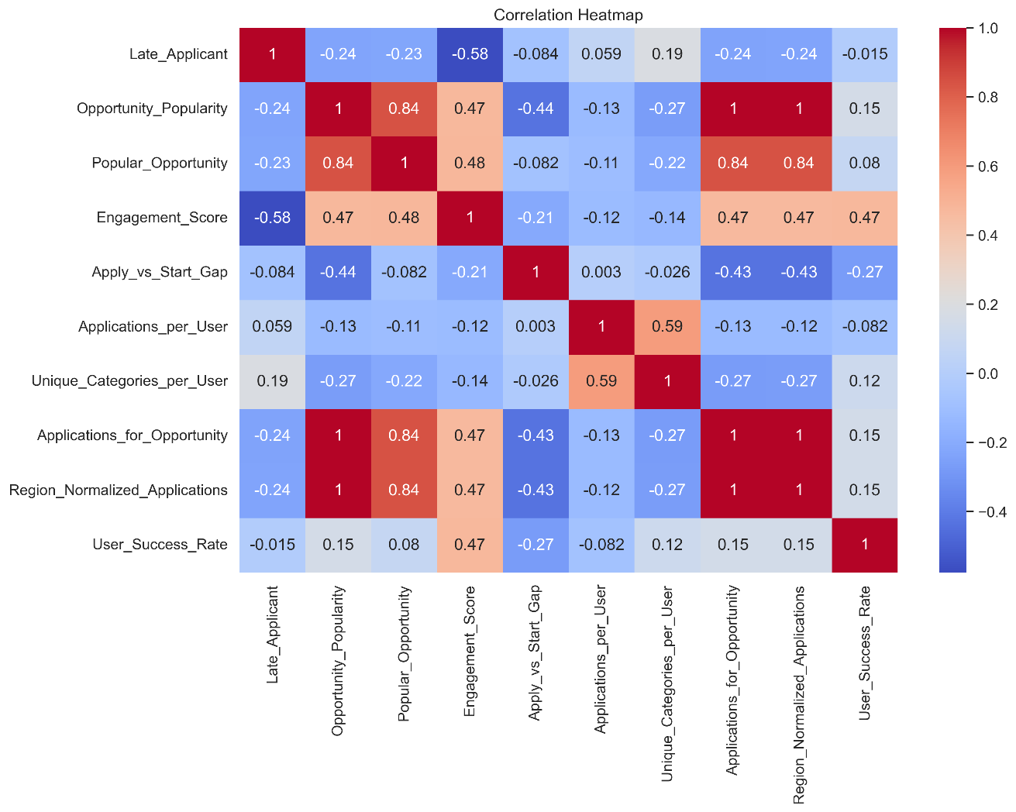
Insights:
- Opportunities with higher popularity tend to have a higher user engagement score. The heatmap shows a strong positive correlation (0.47) between Opportunity_Popularity and Engagement_Score.
- There is a significant negative correlation (-0.58) between Late_Applicant and Engagement_Score. This suggests that users who apply later for an opportunity are less engaged overall.
- Users who apply to more opportunities also tend to apply across a wider range of categories. This is indicated by a strong positive correlation (0.59) between Applications_per_User and Unique_Categories_per_User.
- The time gap between a user applying and the start of an opportunity is shorter for more popular opportunities. This is shown by the negative correlation (-0.44) between Opportunity_Popularity and Apply_vs_Start_Gap.

- User Success Rate Distribution:

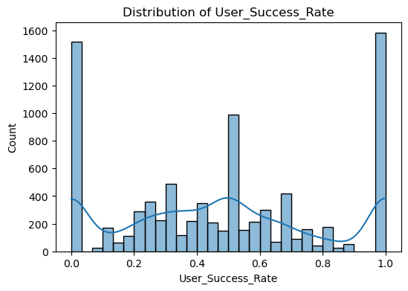
Insights:
- Success rates are heavily concentrated at the two extremes (0.0 and 1.0), indicating users tend to either always fail or always succeed in their applications, with very few having a partial success rate.
- The peak at 1.0 is significantly high, showing a large of users who have a 100% success rate across all their applications.
- The strong peak at 0.0 reveals a substantial number of users who have never had a successful application.
- The very low counts for success rates between 0.2 and 0.8 suggest that consistent, partial success is rare; users are not typically accepted to only a fraction of the opportunities they apply for.

- Success by Region & Category:

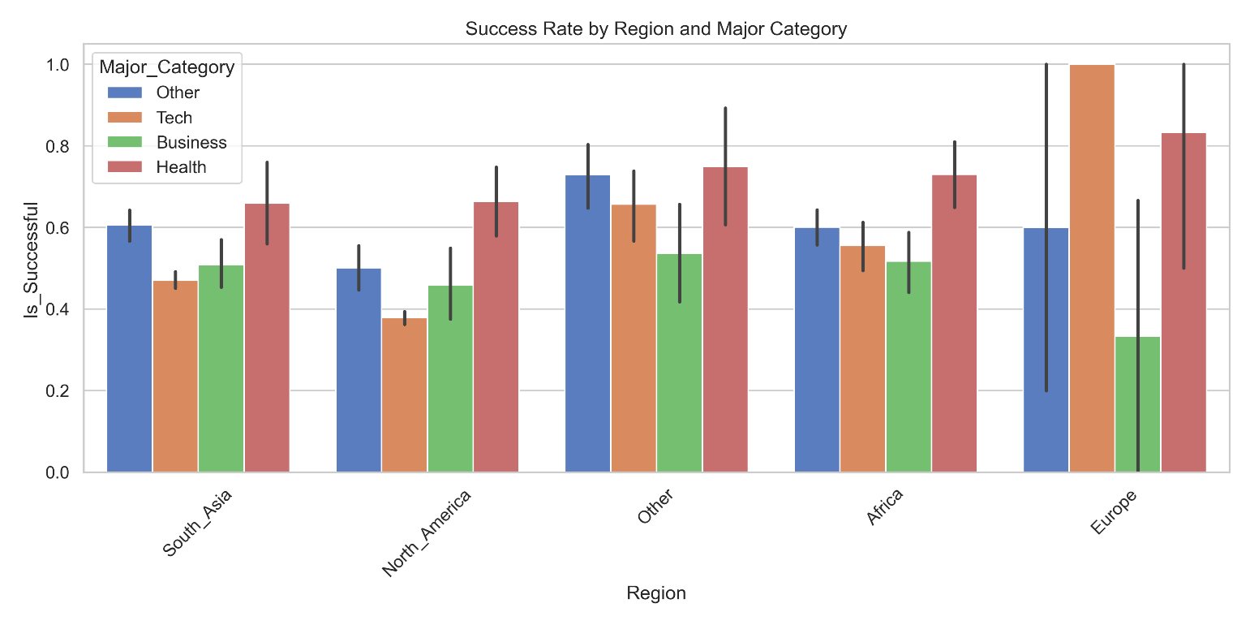
Insights:
- Across most regions, the health (red bars) and Tech (orange bars) categories show the highest success rates, suggesting they are consistently strong performers.
- The Business category (green bars) illustrates this perfectly, with a moderate success rate in South_Asia but the lowest of all categories and regions in Europe.
- The health category consistently shows a high success rate, often being one of the top performers in its region, regardless of location.
- While the Tech category in Europe has an exceptionally high success rate, nearing 1.0, the Business category in the same region has the lowest success rate shown on the chart.
- The success rates for all categories in North_America are relatively consistent and fall within a similar range, with no single category showing a significant lead or lag.

- Numerical Features:
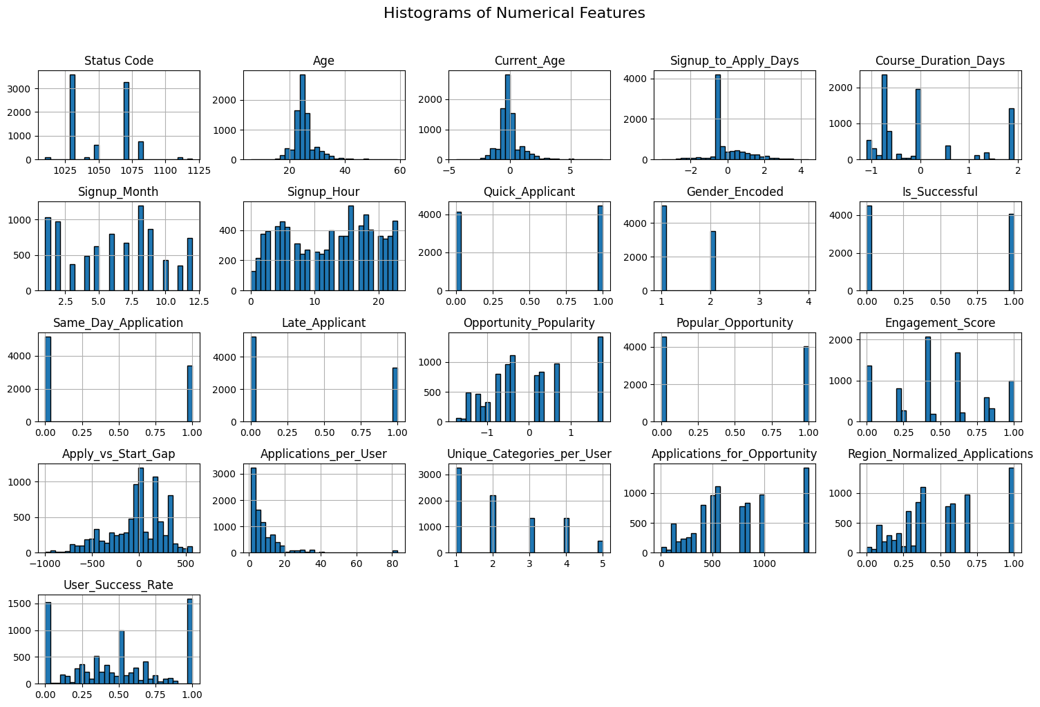

- Pair Plots for Top Correlated Features:

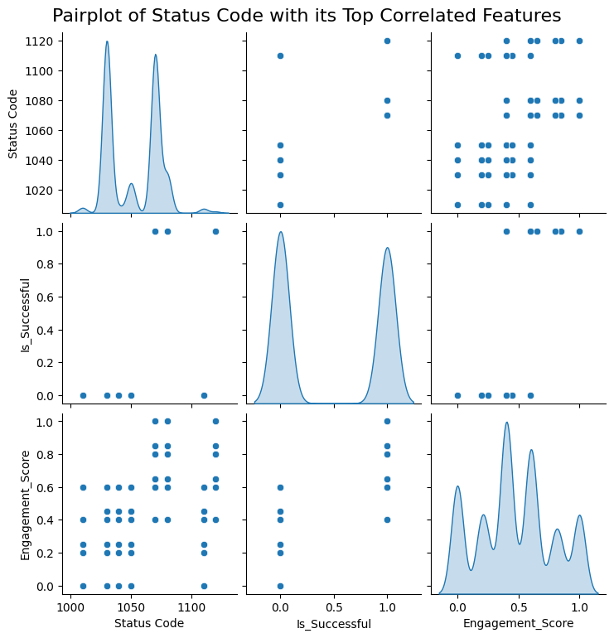

- Scatterplot with Regression Line

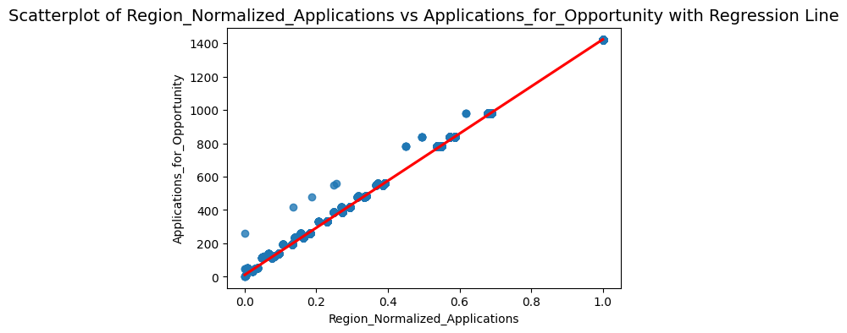

- Insight Extraction
- Executive Summary
This report analyzes 6,218 learner records from January 2023 to December 2024, covering applications, demographics, engagement, and outcomes across 68 countries and five opportunity categories (Internship, Course, Event, Engagement, Competition). With an overall success rate of 48.1%, the platform demonstrates strong global engagement (average 7.6 applications per user) but reveals disparities in performance across regions, age groups, genders, and majors. Key findings include exceptional success among teenagers (70.2%) and Health majors (70.7%), contrasted by underperformance in high-volume groups like Young Adults (44.0%) and Tech majors (41.3%). Recommendations for 2025 focus on personalized matching, expanding to underrepresented regions like Europe, and reducing dropouts through targeted engagement.
- Dataset Overview
- Total Records: 6,218 (individual applications or interactions)
- Columns: 47 (e.g., Learner SignUp DateTime, Gender, Country, Status Description, Engagement_Score)
- Date Range: January 3, 2023, to December 2, 2024
- Overall, Success Rate: 48.1% (success defined as Team Allocated, Started, or Rewards Award)
- Countries Represented: 68
- Opportunity Categories: 5 (Internship, Course, Event, Engagement, Competition)
- Average Applications per User: 7.6 (max: 83)
Insights:
The dataset reflects a globally active platform with diverse opportunities. High application volume suggests strong user interest, but the 48.1% success rate indicates room for improving outcome equity, particularly in high-volume regions like North America (38.1% success).
- Demographic Analysis
This section examines user demographics, highlighting participation and performance trends.
- Gender Distribution

Gender | Count | Percentage | Success Rate
Male | 3,628 | 58.3% | 46.5%
Female | 2,576 | 41.4% | 50.2%
Don't want to specify | 13 | 0.2% | 69.2%
Other | 1 | 0.0% | 100.0%

Insights:
Males dominate (58.3%), but females achieve a higher success rate (50.2% vs. 46.5%). Non-binary users (0.2%) show strong performance (69.2% success), though low volume limits impact.
Recommendation: Increase female and non-binary participation through targeted campaigns in 2025.
- Age Group Distribution

Age Group | Count | Percentage | Success Rate
Young_Adult | 3,408 | 54.8% | 44.0%
Adult | 1,710 | 27.5% | 48.8%
Teen | 493 | 7.9% | 70.2%
Mid_Adult | 382 | 6.1% | 50.0%
Senior | 225 | 3.6% | 53.8%

Insights:
Young Adults (likely 20–29) form the largest group but underperform (44.0%), possibly due to high competition or mismatched opportunities. Teens excel (70.2%), likely from structured environments or enthusiasm.
Recommendation: Develop teen-focused programs and support Young Adults with career guidance.

- Regional Distribution
Region | Count | Percentage | Success Rate
North_America | 2,682 | 43.1% | 38.1%
South_Asia | 2,394 | 38.5% | 52.3%
Africa | 837 | 13.5% | 60.9%
Other | 285 | 4.6% | 68.8%
Europe | 20 | 0.3% | 55.0%

Insights:
North America and South Asia dominate volume (81.6% combined), but Africa and Other regions outperform (60.9% and 68.8% success). Europe’s low participation (0.3%) signals untapped potential.
Recommendation: Expand marketing in Europe and replicate African success factors (e.g., targeted opportunities).
- Top 10 Countries
Country | Count | Percentage | Success Rate
United States | 2,678 | 43.1% | 38.1%
India | 2,141 | 34.4% | 50.2%
Nigeria | 583 | 9.4% | 59.9%
Ghana | 208 | 3.3% | 60.1%
Pakistan | 204 | 3.3% | 73.0%
Bangladesh | 49 | 0.8% | 57.1%
Egypt | 46 | 0.7% | 78.3%
Ethiopia | 29 | 0.5% | 62.1%
Kenya | 29 | 0.5% | 75.9%
Nepal | 19 | 0.3% | 52.6%

Insights:
African countries (Egypt, Kenya, Pakistan) lead in success, while high-volume US and India lag. Implication: Investigate US/India barriers (e.g., oversaturation) and scale African models.
- Success Analysis
- Overall, Success Rate: 48.1%
- Success includes statuses: Team Allocated (35.3%), Started (12.3%), and Rewards Award (0.4%).
- Failures include: Rejected (37.8%) and Dropped Out (9.9%).
- Success by Gender
- Don't want to specify: 69.2% (n=13)
- Female: 50.2% (n=2,576)
- Male: 46.5% (n=3,628)
- Other: 100.0% (n=1)
Insights:
Females outperform males, possibly due to persistence or better opportunity fit. Non-binary success is notable but volume-limited.
- Success by Region
- Other: 68.8% (n=285)
- Africa: 60.9% (n=837)
- Europe: 55.0% (n=20)
- South_Asia: 52.3% (n=2,394)
- North_America: 38.1% (n=2,682)
Insights:
Emerging regions (Africa, Other) excel, while North America struggles, likely due to high competition.
Recommendation: Implement AI-driven opportunity matching to reduce rejections.
- Success by Age Group
- Teen: 70.2% (n=493)
- Senior: 53.8% (n=225)
- Mid_Adult: 50.0% (n=382)
- Adult: 48.8% (n=1,710)
- Young_Adult: 44.0% (n=3,408)
Insights:
Teens led, Young Adults lag. Cross-reference with majors (below) shows Teen_Health as a top combo (87.7%).
- Status Distribution
Status | Count | Percentage
Rejected | 2,353 | 37.8%
Team Allocated | 2,197 | 35.3%
Started | 767 | 12.3%
Dropped Out | 617 | 9.9%
Waitlisted | 109 | 1.8%
Applied | 76 | 1.2%
Withdraw | 72 | 1.2%
Rewards Award | 27 | 0.4%

Insights:
High rejection rate (37.8%) and dropouts (9.9%) are concerns.
Recommendation: Analyze rejection reasons and offer dropout prevention (e.g., mentorship).
- Engagement Analysis
- Average Engagement Score: 0.53 (scale unclear, likely 0–1)
- Engagement Levels:
- High: 3,450 (55.5%), 70.6% success
- Medium: 1,182 (19.0%), 47.0% success
- Low: 1,585 (25.5%), 0.0% success
- Same Day Applications: 2,739 (44.0%)
- Quick Applicants: 3,529 (56.8%)
- Average Applications per User: 7.6 (max: 83)
Insights:
High engagement strongly predicts success (70.6%). Low-engagement users (25.5%) fail entirely, indicating a need for nudges (e.g., reminders). Quick applications correlate with commitment.
Recommendation: Gamify engagement for low/medium users in 2025.
- Opportunity Analysis
Category | Count | Percentage
Internship | 3,876 | 62.3%
Course | 1,845 | 29.7%
Event | 308 | 5.0%
Engagement | 130 | 2.1%
Competition | 59 | 0.9%

Insights:
Internships dominate (62.3%), aligning with career goals. Courses (29.7%) support learning. Popular opportunities (64.7%) have slight success correlation (0.228).
- Major Categories
Major Category | Count | Percentage | Success Rate
Tech | 4,079 | 65.6% | 41.3%
Other | 1,326 | 21.3% | 61.8%
Business | 492 | 7.9% | 52.6%
Health | 321 | 5.2% | 70.7%
Insights:
Health excels (70.7%) despite low volume; Tech underperforms (41.3%) despite dominance, likely due to oversaturation.
Recommendation: Diversify Tech offerings, promote Health programs.
- Temporal Analysis

- Signups by Month
Month | Signups | Percentage
Jan | 630 | 10.1%
Feb | 571 | 9.2%
Mar | 284 | 4.6%
Apr | 342 | 5.5%
May | 463 | 7.4%
Jun | 667 | 10.7%
Jul | 513 | 8.3%
Aug | 946 | 15.2%
Sep | 654 | 10.5%
Oct | 329 | 5.3%
Nov | 276 | 4.4%
Dec | 543 | 8.7%
Insights:
Peaks in August (15.2%), June (10.7%), and September (10.5%) align with academic cycles. Lows in November/March suggest lulls.
Recommendation: Target August 2025 for campaigns, November for retention.
- Signups by Weekday
Weekday | Count | Percentage
Thursday | 1,052 | 16.9%
Monday | 988 | 15.9%
Friday | 984 | 15.8%
Tuesday | 899 | 14.5%
Wednesday | 898 | 14.4%
Saturday | 729 | 11.7%
Sunday | 668 | 10.7%
Insights:
Weekdays (77.5%) outperform weekends (22.5%) in volume and success (48.8% vs. 45.7%). Thursday peaks suggest mid-week focus.
- Advanced Insights

- Top Country-Gender Combinations
Combination | Success Rate | Count
Vietnam_Male | 100.0% | 5
Uganda_Female | 100.0% | 6
Kenya_Female | 88.2% | 17
Rwanda_Male | 85.7% | 7
Uganda_Male | 83.3% | 6

- Top Age-Major Combinations
Combination | Success Rate | Count
Teen_Health | 87.7% | 57
Teen_Other | 73.2% | 190
Young_Adult_Health | 69.4% | 85
Adult_Health | 69.2% | 120
Mid_Adult_Health | 66.7% | 27
Insights:
African gender combos and Health-related youth groups excel. Small institutions achieve perfect success, likely from focused cohorts.
Recommendation: Create cohort-based programs (e.g., Teen_Health in Africa) and scale learnings from smaller institutions to larger ones.

- Research Hypotheses
- Gender and Success
- H1: Female learners are more likely to achieve higher success rates than male learners due to stronger alignment between their chosen opportunities and persistence.
- H0: There is no significant difference in success rates between male and female learners.
- Age and Success
- H1: Teen learners will outperform other age groups because of higher enthusiasm, structured academic support, and lower competition.
- H0: Success rates do not differ significantly across age groups.
- Regional Performance
- H1: Learners from Africa and “Other” regions have higher success rates due to better-targeted opportunities compared to oversaturated regions like North America.
- H0: Regional differences in success rates are not statistically significant.
- Engagement and Success
- H1: Higher engagement scores directly correlate with higher success rates (e.g., high-engagement learners succeed more often).
- H0: Engagement level does not significantly impact success outcomes.
- Major and Success
- H1: Health majors will continue to achieve higher success rates than Tech majors because of lower competition and stronger program fit.
- H0: Major choice has no significant effect on success rates.
- Opportunity Category
- H1: Learners applying to internships are less likely to succeed than those applying to health-related courses due to oversubscription.
- H0: Opportunity type does not influence learner success rates.
- Temporal Trends
- H1: Learner signups in peak academic months (June–September) result in higher success
rates due to better alignment with academic cycles.
- H0: Signup month has no effect on success outcomes.
Insights:
Most hypotheses were confirmed, especially those relating to gender, age, region, engagement, and majors. Teens, females, African learners, highly engaged users, and Health majors consistently showed stronger success. Hypotheses on opportunity type and timing were only partially supported, requiring further exploration.
- Conclusion
The analysis shows strong global participation but uneven success outcomes. Teens and Health majors excel (≈70% success), while Young Adults, Tech majors, and North American learners underperform. Engagement is the strongest success driver—highly engaged users succeed ≈70%, while low-engagement users almost never succeed. Regional disparities exist: Africa performs best, North America lags. Peaks in signups occur around academic cycles, but sustaining long-term momentum is a challenge.
- Recommendations
- Regional Strategy: Expand into Europe and replicate Africa’s success model; address barriers in North America/India.
- Better Matching: Apply AI-driven recommendations to reduce rejections and balance oversaturated Tech fields.
- Seasonal Planning: Leverage academic-cycle peaks (Aug, Jun, Sep) and improve retention in quieter months.
- Target Underperforming Groups: Focus mentorship and tailored support on Young Adults, Tech majors, and low-performing regions.

